SQL Server Integration Services

# Module 03: CONTROL FLOW: SQL Execute TASK (single row/value)

1. Launch SQL Server Data Tools (SSDT), under start menu look for Visual Studio 2017 (SSDT).
2. In the Start Page, click Create new project.  
   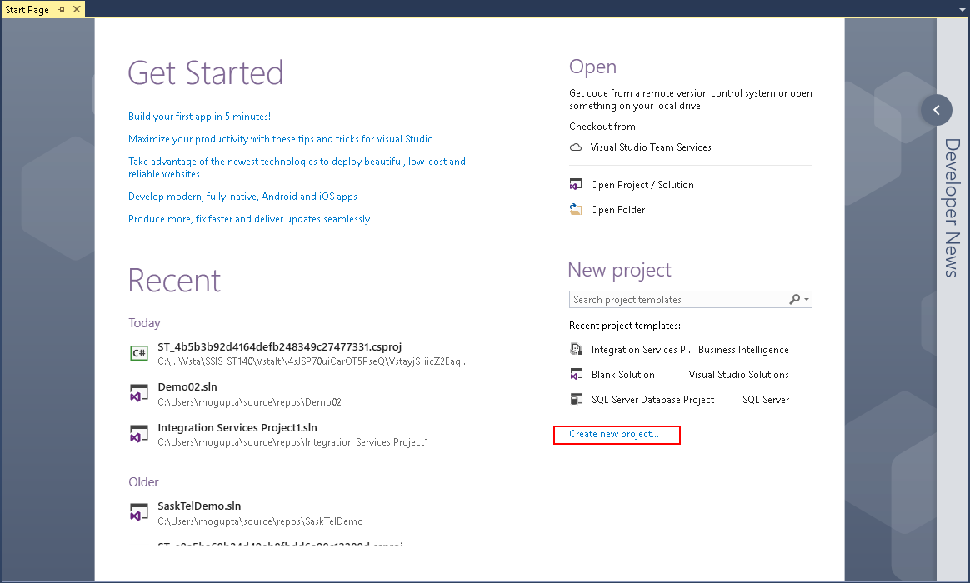
3. In New Project dialog box select Business Intelligence > Integration Services > Integration Services Project. On the bottom enter in project name and location you wish to save the project. Make sure “Create directory for solution” is selected and click OK.

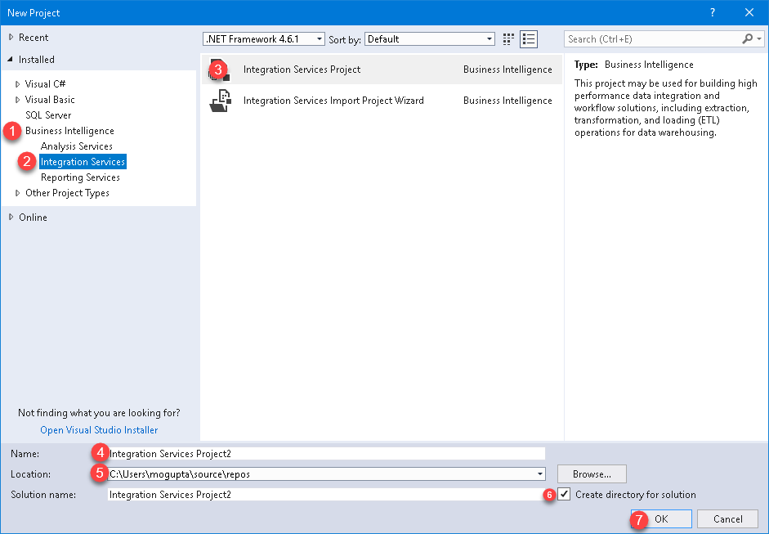

1. In the SSIS Menu select Variables.  
   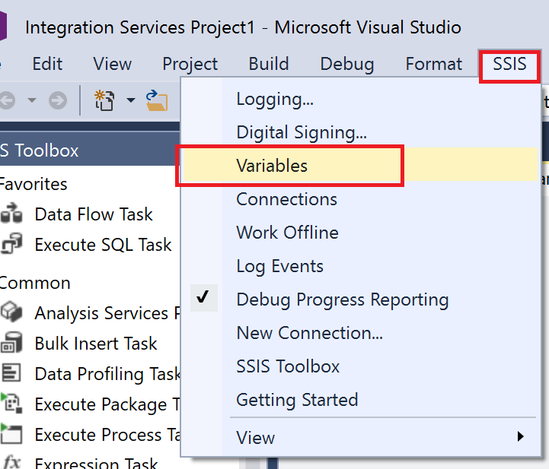
2. Click on the New Variable icon.  
   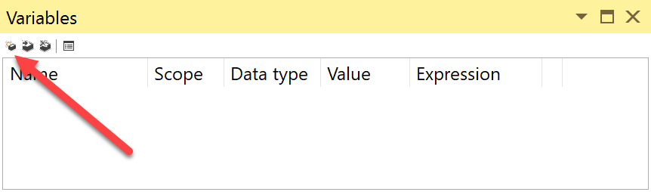
3. Rename the Variable to SQLVersion of String Data Type.

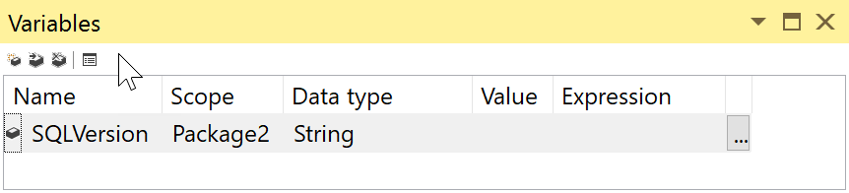

1. Double-click **Script Task** from SSIS Toolbox, to add onto the Control Flow canvas.
2. Set Script Task’s ReadOnlyVariables property to User::SQLVersion in the Script Task Editor, then click on Edit Script.

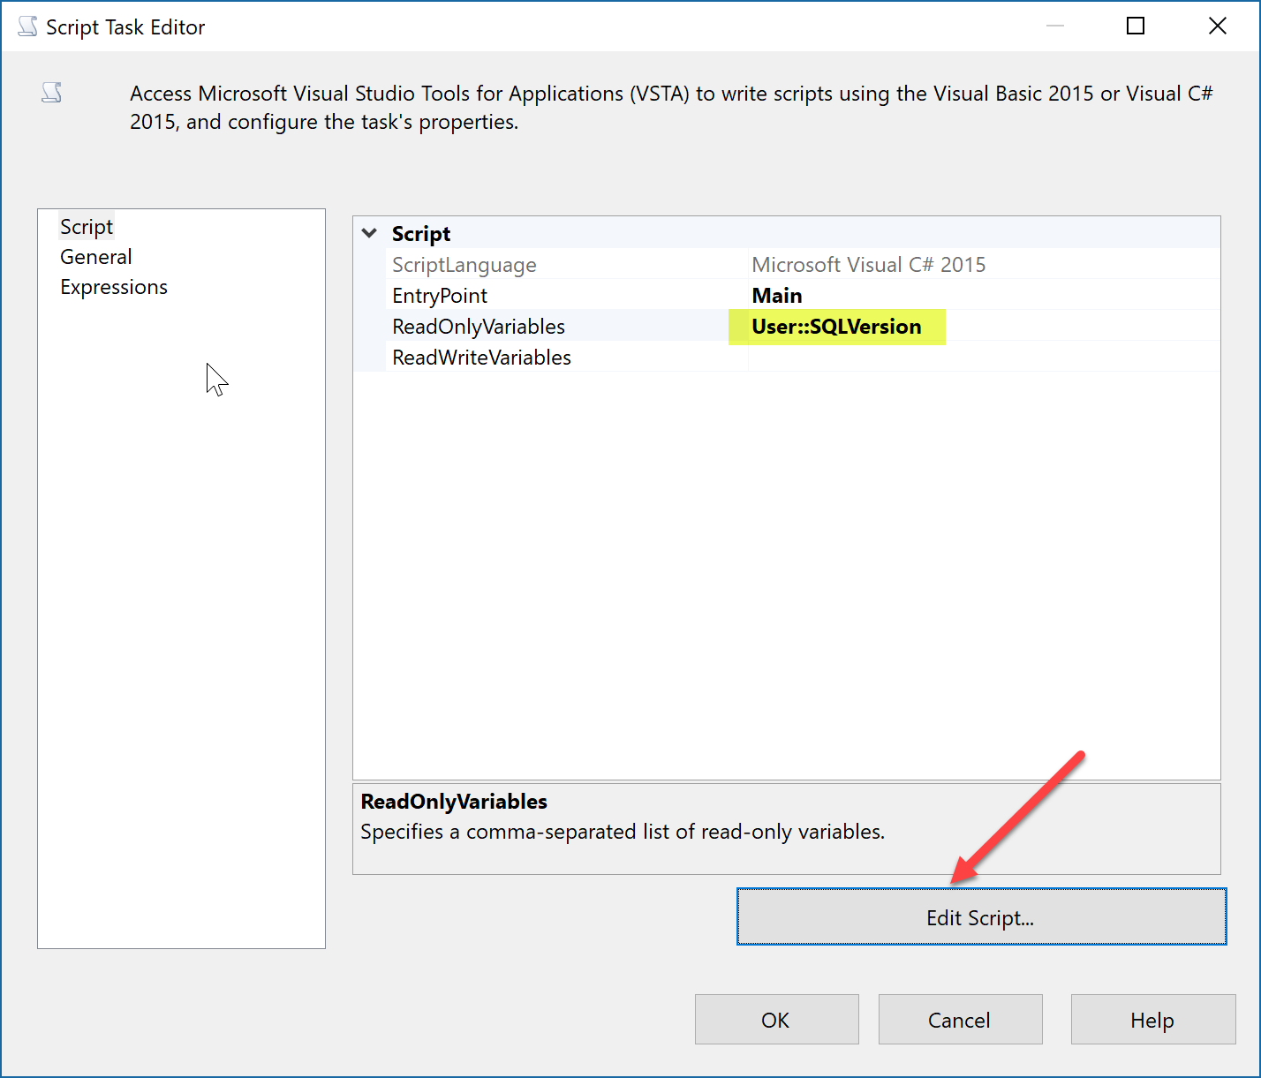

1. In the VstaProjects window, Add following code line into the main() block.

MessageBox.Show(Dts.Variables["User::SQLVersion"].Value.ToString());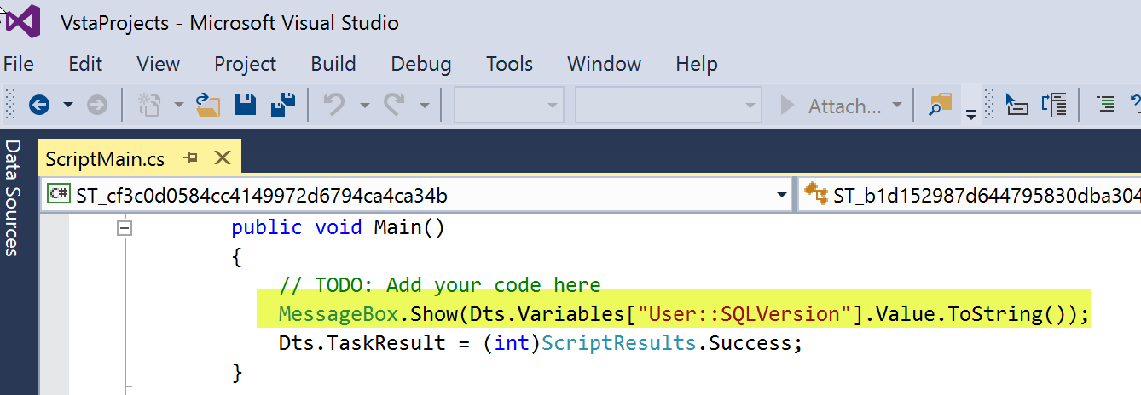

1. Close the VstaProjects, and then click on OK to close the Script Task Editor Dialog.
2. Double-click on **Execute SQL Task** from SSIS toolbox, to add onto Control Flow canvas.
3. Drag Green arrow from Execute SQL Task to Script Task.

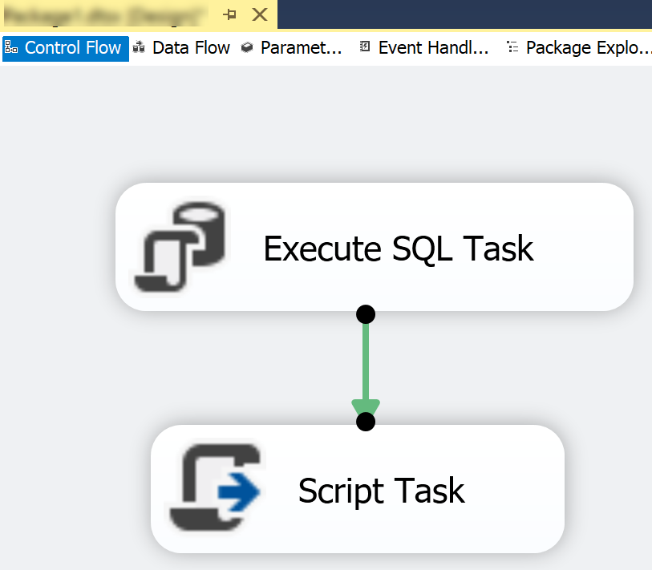

1. Double click on the Execute SQL Task on the Control Flow canvas, and Set the Connection.

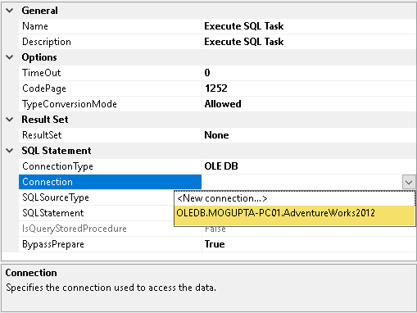

1. Set ResultSet to SingleRow and set SQLStatement to following script.

SELECT @@VERSION

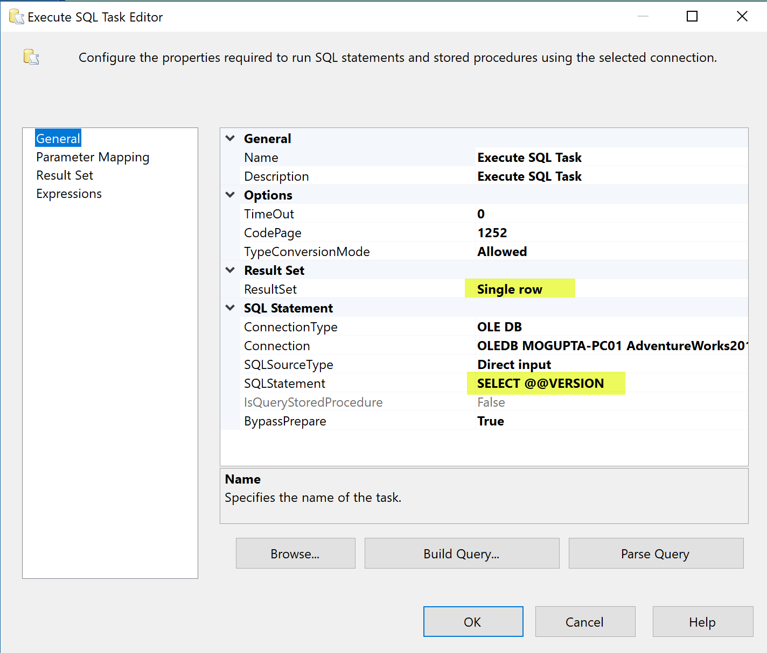

1. After the data is retuned we must capture it to a variable if we wish to use it later. Select the Result Set tab and assign the output to the variable we defined.

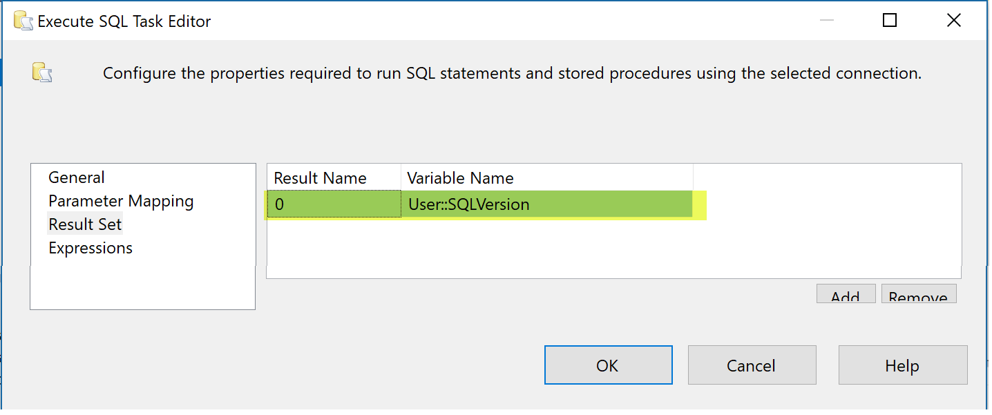

1. Click OK to close the Execute SQL Task Editor.
2. Execute the Package.

